Remote assignment

**Part I: Poster display**

We would like you to bring a poster that can be up to [841mm TALL x 594mm WIDE] that summarizes your research. Posters will be set up on the 13th and will be displayed throughout the full workshop.

**Part II: Please buy the following components.**

**(Pls find them in electronic stores in your country/city)**

**Don’t order them from Alibaba/AliExpress…!**

This is a hands-on training you will be attending. We will need a minimum of components that will be used to demonstrate how to build a low-cost air quality monitoring system. We have selected the list of components below to lower the cost of the demo and keep it below EUR 100.

1- USB to type c data cable (1 pcs) [suitable for ESP32]

<https://www.alibaba.com/product-detail/Toocki-Wholesale-3A-Fast-Charging-Smart_1600827326786.html?spm=a2700.galleryofferlist.p_offer.d_image.3ee13b51n3cdIP&s=p>

2-DS3231 AT24C32 IIC Precision RTC (1 pcs) [with batteries]

[https://www.aliexpress.com/item/1005005216959684.html?spm=a2g0o.productlist.main.1.63cc628bt7Nouz&algo_pvid=3b0c4487-9a81-4eb8-b3d5-c0a788a91771&algo_exp_id=3b0c4487-9a81-4eb8-b3d5-c0a788a91771-0&pdp_npi=4%40dis%21EUR%211.15%211.01%21%21%211.23%21%21%402103011117033215917397370e5afb%2112000036724540573%21sea%21CH%21132321444%21&curPageLogUid=w1xWnQx0YfFs](https://www.aliexpress.com/item/1005005216959684.html?spm=a2g0o.productlist.main.1.63cc628bt7Nouz&algo_pvid=3b0c4487-9a81-4eb8-b3d5-c0a788a91771&algo_exp_id=3b0c4487-9a81-4eb8-b3d5-c0a788a91771-0&pdp_npi=4@dis!EUR!1.15!1.01!!!1.23!!@2103011117033215917397370e5afb!12000036724540573!sea!CH!132321444!&curPageLogUid=w1xWnQx0YfFs)

3- core ESP32-DevKitC-32 ESP-WROOM-32 (1 pcs)

[https://de.aliexpress.com/item/1005005972312714.html?spm=a2g0o.productlist.main.1.6f70jXbcjXbcBX&algo_pvid=8e9ee055-e263-4286-b3af-fb8697216f32&algo_exp_id=8e9ee055-e263-4286-b3af-fb8697216f32-0&pdp_npi=4%40dis%21CHF%218.51%212.79%21%21%2169.57%21%21%402101c5a417033201488621184e43da%2112000035116542270%21sea%21CH%21132321444%21&curPageLogUid=EvkoJrv54hvP](https://de.aliexpress.com/item/1005005972312714.html?spm=a2g0o.productlist.main.1.6f70jXbcjXbcBX&algo_pvid=8e9ee055-e263-4286-b3af-fb8697216f32&algo_exp_id=8e9ee055-e263-4286-b3af-fb8697216f32-0&pdp_npi=4@dis!CHF!8.51!2.79!!!69.57!!@2101c5a417033201488621184e43da!12000035116542270!sea!CH!132321444!&curPageLogUid=EvkoJrv54hvP)

4- PMS5003 dust sensor + G5 switch board and cable (1 pcs) (This component can be scarce…if you don’t have it pls don’t worry)

[https://www.aliexpress.com/item/1005004843493712.html?spm=a2g0o.productlist.main.1.7cba6f6fqLKgj3&algo_pvid=ce9a2c17-6949-4994-918d-8506b091690e&algo_exp_id=ce9a2c17-6949-4994-918d-8506b091690e-0&pdp_npi=4%40dis%21EU%2129.10%2118.91%21%21%2131.22%2120.29%21%40210307c117051429981778696e02d0%2112000030711881850%21sea%21AT%21132321444%21&curPageLogUid=sK9IsyGcjPlN&utparam-url=scene%3Asearch%7Cquery_from%3A](https://www.aliexpress.com/item/1005004843493712.html?spm=a2g0o.productlist.main.1.7cba6f6fqLKgj3&algo_pvid=ce9a2c17-6949-4994-918d-8506b091690e&algo_exp_id=ce9a2c17-6949-4994-918d-8506b091690e-0&pdp_npi=4@dis!EUR!29.10!18.91!!!31.22!20.29!@210307c117051429981778696e02d0!12000030711881850!sea!AT!132321444!&curPageLogUid=sK9IsyGcjPlN&utparam-url=scene%3Asearch|query_from%3A)

5- Micro SD card mini TF card reader module (1 pcs)

[https://www.aliexpress.com/item/1005005981296699.html?spm=a2g0o.productlist.main.1.1ad7795d8yxdOu&algo_pvid=34068911-5a65-49ce-ab3b-f8131c90d834&algo_exp_id=34068911-5a65-49ce-ab3b-f8131c90d834-0&pdp_npi=4%40dis%21EUR%213.42%211.12%21%21%2126.26%21%21%402103011117033214285495813e5afb%2112000035161262331%21sea%21CH%21132321444%21&curPageLogUid=SupuWCgnKgOE](https://www.aliexpress.com/item/1005005981296699.html?spm=a2g0o.productlist.main.1.1ad7795d8yxdOu&algo_pvid=34068911-5a65-49ce-ab3b-f8131c90d834&algo_exp_id=34068911-5a65-49ce-ab3b-f8131c90d834-0&pdp_npi=4@dis!EUR!3.42!1.12!!!26.26!!@2103011117033214285495813e5afb!12000035161262331!sea!CH!132321444!&curPageLogUid=SupuWCgnKgOE)

6- memory cards 4 GB (1 pcs)

[https://www.aliexpress.com/item/1005001617961938.html?spm=a2g0o.productlist.main.3.1a606e14ziD3AU&algo_pvid=fd632546-7795-4e47-a09f-c429ad2cf88e&algo_exp_id=fd632546-7795-4e47-a09f-c429ad2cf88e-1&pdp_npi=4%40dis%21EUR%215.57%211.61%21%21%215.98%21%21%402103011117033214772846356e5afb%2112000016836623831%21sea%21CH%21132321444%21&curPageLogUid=6l9BbxnbzuNN](https://www.aliexpress.com/item/1005001617961938.html?spm=a2g0o.productlist.main.3.1a606e14ziD3AU&algo_pvid=fd632546-7795-4e47-a09f-c429ad2cf88e&algo_exp_id=fd632546-7795-4e47-a09f-c429ad2cf88e-1&pdp_npi=4@dis!EUR!5.57!1.61!!!5.98!!@2103011117033214772846356e5afb!12000016836623831!sea!CH!132321444!&curPageLogUid=6l9BbxnbzuNN)

7- DHT11 Digital Temperature & Humidity Sensor Module (1 pcs)

[https://www.aliexpress.com/item/1005006170353904.html?spm=a2g0o.productlist.main.3.49f93662TrAuhL&algo_pvid=53d19b4e-da0d-450f-8fab-94b73f84dc5b&algo_exp_id=53d19b4e-da0d-450f-8fab-94b73f84dc5b-1&pdp_npi=4%40dis%21EUR%215.95%212.86%21%21%2145.70%21%21%402103011117033211059202640e5afb%2112000036095162376%21sea%21CH%21132321444%21&curPageLogUid=Ni1LfMzvllrU](https://www.aliexpress.com/item/1005006170353904.html?spm=a2g0o.productlist.main.3.49f93662TrAuhL&algo_pvid=53d19b4e-da0d-450f-8fab-94b73f84dc5b&algo_exp_id=53d19b4e-da0d-450f-8fab-94b73f84dc5b-1&pdp_npi=4@dis!EUR!5.95!2.86!!!45.70!!@2103011117033211059202640e5afb!12000036095162376!sea!CH!132321444!&curPageLogUid=Ni1LfMzvllrU)

8- LCD2004+I2C LCD2004 20x4 2004A Green Screen (1 pcs)

[https://www.aliexpress.com/item/1005005973980073.html?spm=a2g0o.productlist.main.7.115435d4SCAfX0&algo_pvid=d5bdb40c-e2c0-4cef-a3d0-212eb1d2c8af&algo_exp_id=d5bdb40c-e2c0-4cef-a3d0-212eb1d2c8af-3&pdp_npi=4%40dis%21EUR%215.09%213.31%21%21%2139.07%21%21%402101c5a417033206555666290e43da%2112000035125818492%21sea%21CH%21132321444%21&curPageLogUid=yuEEIxjlwBTn](https://www.aliexpress.com/item/1005005973980073.html?spm=a2g0o.productlist.main.7.115435d4SCAfX0&algo_pvid=d5bdb40c-e2c0-4cef-a3d0-212eb1d2c8af&algo_exp_id=d5bdb40c-e2c0-4cef-a3d0-212eb1d2c8af-3&pdp_npi=4@dis!EUR!5.09!3.31!!!39.07!!@2101c5a417033206555666290e43da!12000035125818492!sea!CH!132321444!&curPageLogUid=yuEEIxjlwBTn)

9- Breadboard 400 830 Holes Prototype Board MB-102 Solderless PCB Mini Test Board Jumper Wire Cable DIY Kit (1 pcs)

[https://www.aliexpress.com/item/1005006267512484.html?spm=a2g0o.productlist.main.31.5df73813oCKXDu&algo_pvid=a62704c8-82fd-4506-b695-756d7e6da46c&algo_exp_id=a62704c8-82fd-4506-b695-756d7e6da46c-15&pdp_npi=4%40dis%21CHF%2112.31%214.04%21%21%21100.68%21%21%402101c5a417033202897432784e43da%2112000036536145019%21sea%21CH%21132321444%21&curPageLogUid=TnqQFCAf4OX2](https://www.aliexpress.com/item/1005006267512484.html?spm=a2g0o.productlist.main.31.5df73813oCKXDu&algo_pvid=a62704c8-82fd-4506-b695-756d7e6da46c&algo_exp_id=a62704c8-82fd-4506-b695-756d7e6da46c-15&pdp_npi=4@dis!CHF!12.31!4.04!!!100.68!!@2101c5a417033202897432784e43da!12000036536145019!sea!CH!132321444!&curPageLogUid=TnqQFCAf4OX2)

10- 2.54MM 40P color DuPont line female to female (1 pcs)/ male to female (1 pcs)/ male to male head (1 pcs), 30 CM length

[https://www.aliexpress.com/item/1005005501503609.html?spm=a2g0o.productlist.main.5.3ee824a8GmoFvK&algo_pvid=50fd24ff-c7d4-4fd0-9dbc-b528dbb4a9c1&algo_exp_id=50fd24ff-c7d4-4fd0-9dbc-b528dbb4a9c1-2&pdp_npi=4%40dis%21EUR%210.52%210.29%21%21%210.55%21%21%402103250717043535187017259e0c43%2112000033328892984%21sea%21SN%212602810541%21AB&curPageLogUid=cQWy3xuibRPe](https://www.aliexpress.com/item/1005005501503609.html?spm=a2g0o.productlist.main.5.3ee824a8GmoFvK&algo_pvid=50fd24ff-c7d4-4fd0-9dbc-b528dbb4a9c1&algo_exp_id=50fd24ff-c7d4-4fd0-9dbc-b528dbb4a9c1-2&pdp_npi=4@dis!EUR!0.52!0.29!!!0.55!!@2103250717043535187017259e0c43!12000033328892984!sea!SN!2602810541!AB&curPageLogUid=cQWy3xuibRPe)

**Part III: Work on your computer that you will take along with you.**

You will have to bring your computer… pls follow the instructions below.

**Useful links and Materials for the workshop**

The materials and resources for the workshop are available here:

Github: <https://github.com/uraich/IoT4AQ>

twiki: <https://afnog.iotworkshop.africa/do/view/Main/WebHome>

website: <https://iot4aq.org/>

Development software installation

1. Install on your computer: Arduino SDK: <https://www.arduino.cc/en/software>  
   There are versions for Linux, Windows, and Mac  
   Please use version 2.3.2 (latest version)
2. Run the SDK:

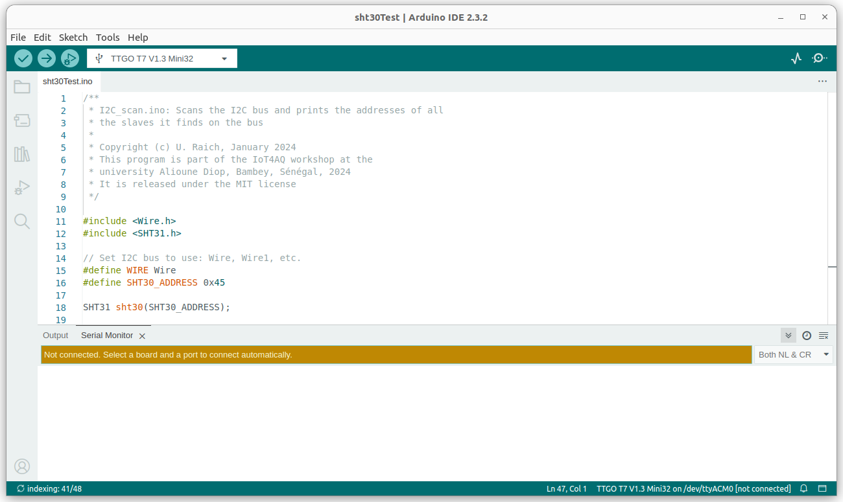

1. Install the ESP32 compiler and tools:  
   Tools → Board → BoardsManager  
   Type ESP32 in the filter field and select esp32 by Espressif (version 2.0.11) and install
2. Install libraries:
   * DHT11 by Dhruba Saha
   * ESP32Time by fbiego
   * RTClib by Adafruit
   * ThingSpeak by Mathworks
3. You may download LIQUIDCrystal_I2C.zip and PMS5003.zip from <https://github.com/uraich/IoT4AQ/tree/main/workshop/libraries>  
   and install the libraries with Sketch → Include Library → Add .zip library
4. Install git from <https://git-scm.com/download>